FOR IMMEDIATE RELEASE
Media Contact:
NAME
TITLE
AFFILIATE
PHONE
EMAIL
CERTIFIED FINANCIAL PLANNER Professionals in Territory Tops XX,XXX

CFP professionals worldwide now surpass 213,000

LOCATION – X February 2023 – AFFILIATE, <<short organization description>>, reports the number of CFP professionals in Territory has reached XX,XXX. With a gain of XXX CFP professionals last year, AFFILIATE grew the number of CFP professionals in Territory by X.X% to a total of XX,XXX, as of 31 December 2022. The CFP professional growth in Territory is part of a growing global trend, where last year the number of CFP professionals around the world reached an all-time high of 213,002.

“We’re pleased to report the number of CERTIFIED FINANCIAL PLANNER professionals worldwide continues to grow, reaching its highest ever at over 213,000. Our robust global community of CFP professionals means people around the world have access to financial planning from those who have committed to rigorous standards of competency, ethics and practice,” said FPSB CEO Dante De Gori, CFP. “With global economic uncertainty and the rising costs of living impacting so many, increased access to financial planning advice is of utmost importance to help individuals and families stay on track to reach their goals and achieve financial well-being.”

AFFILIATE has seen strong growth in the Territory CFP professional community, with X.X% increase of CFP professionals since administering the CFP certification program in YEAR. Recent efforts including TOP reasons CFP professional growth has occurred in your territory can be attributed to last year’s growth.

“On the global stage, increasing the number of CFP professionals nearly two and a half times around the world since FPSB’s creation in 2004 reinforces the value CFP certification holds in the global financial planning profession,” added De Gori. “We commend the hundreds of thousands of CFP professionals worldwide who support the advancement of the financial planning profession, with CFP certification its symbol of excellence.”

To learn more about worldwide CFP professional growth in 2022, view the infographic.

AFFILIATE is part of the FPSB Network. Financial Planning Standards Board Ltd. (FPSB) is the standards-setting body for the global financial planning profession and owner of the international CERTIFIED FINANCIAL PLANNER certification program outside the United States, representing 213,002 CFP professionals worldwide.

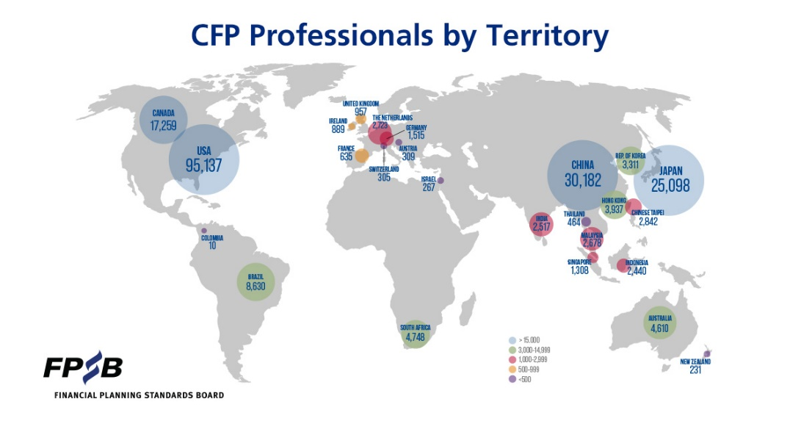

About AFFILIATE

AFFILIATE BOILERPLATE

About FPSB Ltd.
FPSB manages, develops and operates certification, education and related programs to benefit the global community by establishing, upholding and promoting worldwide professional standards in financial planning. FPSB demonstrates its commitment to excellence with the marks of professional distinction – CFP, CERTIFIED FINANCIAL PLANNER and – which it owns internationally. FPSB and the FPSB global network administer CFP certification and other programs in the following 27 territories: Australia, Austria, Brazil, Canada, Chinese Taipei, Colombia, France, Germany, Hong Kong, India, Indonesia, Ireland, Israel, Japan, Malaysia, the Netherlands, New Zealand, People’s Republic of China, Peru, Republic of Korea, Singapore, South Africa, Switzerland, Thailand, Turkey, the United Kingdom and the United States. At the end of 2022, there were 213,002 CFP professionals worldwide. For more, visit fpsb.org.
# # #
CFP Certification Global excellence in financial planning™

